**DAILY ONLINE ACTIVITIES SUMMARY**

|  |  |  |  |  |  |  |  |  |
| --- | --- | --- | --- | --- | --- | --- | --- | --- |
| **Date:** | **26/05/2020** | | | | | **Name:** | **POOJA D S** | |
| **Sem & Sec** | **4th SEM 'B' Section** | | | | | **USN:** | **4AL18CS056** | |
| **Online Test Summary** | | | | | | | | |
| **Subject** | | **Design and Analysis of Algorithms** | | | | | | |
| **Max. Marks** | | **30** | | **Score** | | | **19** | |
| **Certification Course Summary** | | | | | | | | |
| **Course** | **Java Programming** | | | | | | | |
| **Certificate Provider** | | | **Great Learning Academy** | | **Duration** | | | **3.5 hour** |
| **Coding Challenges** | | | | | | | | |
| **Problem Statement:** A user will input two strings, and we find if one of the strings is a sub sequence of the other. Program prints “yes” if either the first string is a sub sequence of the second string or the second string is a sub sequence of the first string. Assume that, the length of the first string is smaller than or equal to the length of the second string. Assume that, the length of the first string is smaller than or equal to the length of the second string. | | | | | | | | |
| **Status: completed** | | | | | | | | |
| **Uploaded the report in Github** | | | | | **yes** | | | |
| **If yes Repository name** | | | | | <https://github.com/dspooja/C-coding>  <https://github.com/dspooja/Java-coding> | | | |
| **Uploaded the report in slack** | | | | | **yes** | | | |

Online Test Details: (Attach the snapshot and briefly write the report for the same)

Certification Course Details: (Attach the snapshot and briefly write the report for the same)

Coding Challenges Details: (Attach the snapshot and briefly write the report for the same)

ONLINE TEST DETAILS:

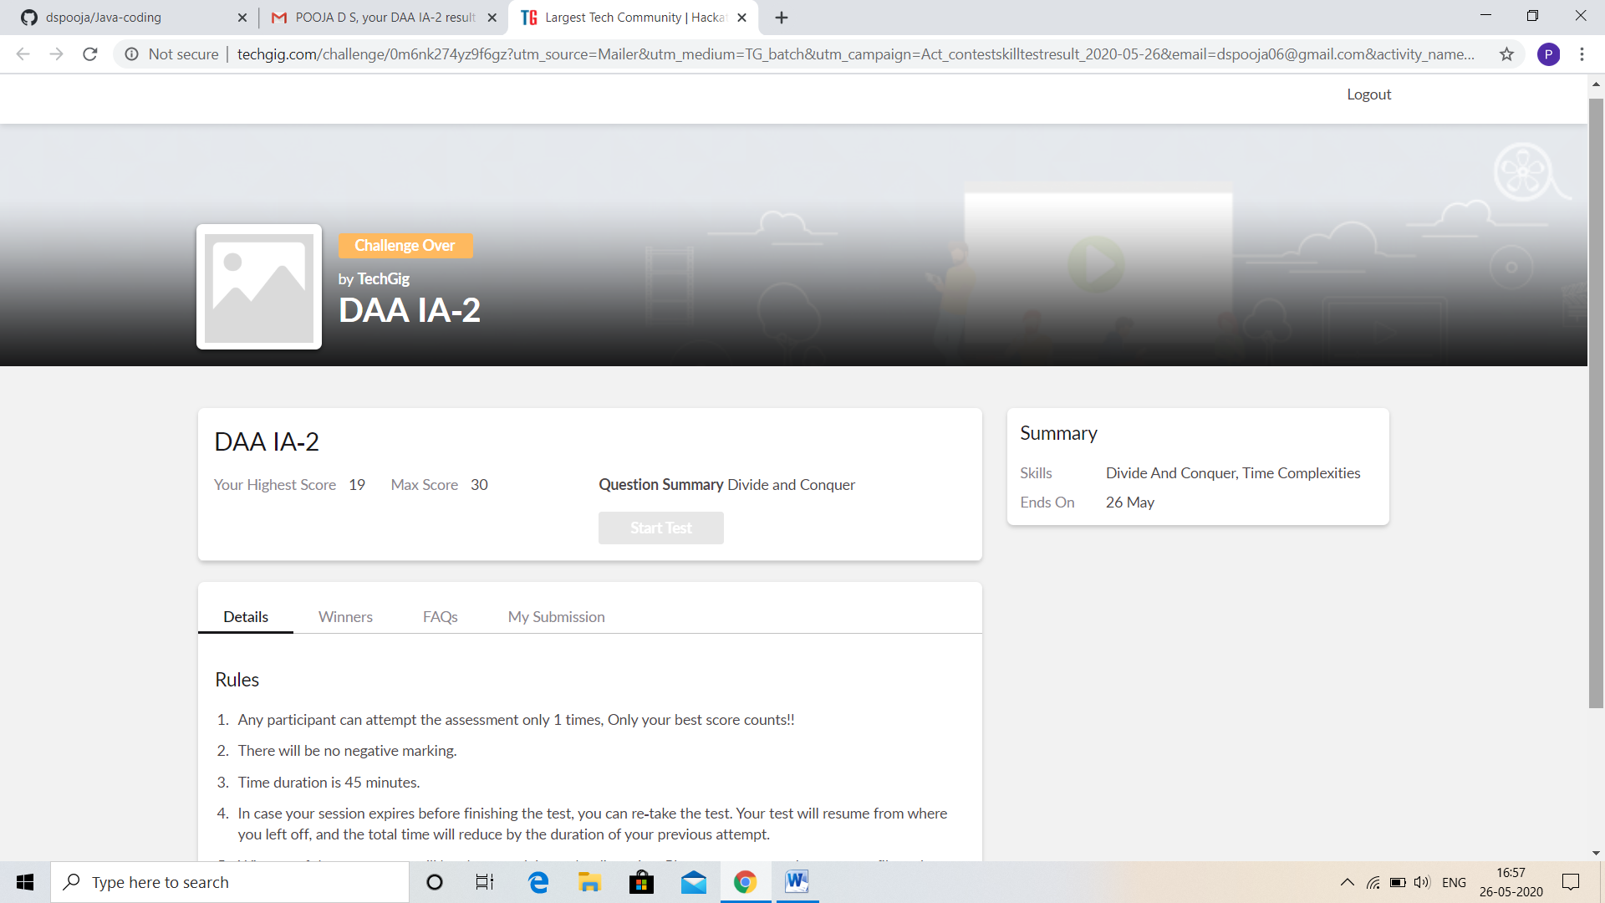

CERTIFICATION COURSE DETAILS:

* As continuation of the online course Java Programming
* **The concepts covered in** Java Programming **are:**
* Functions in Java
* Object Oriented Programming in Java
* Inheritance in Java
* Collection in Java

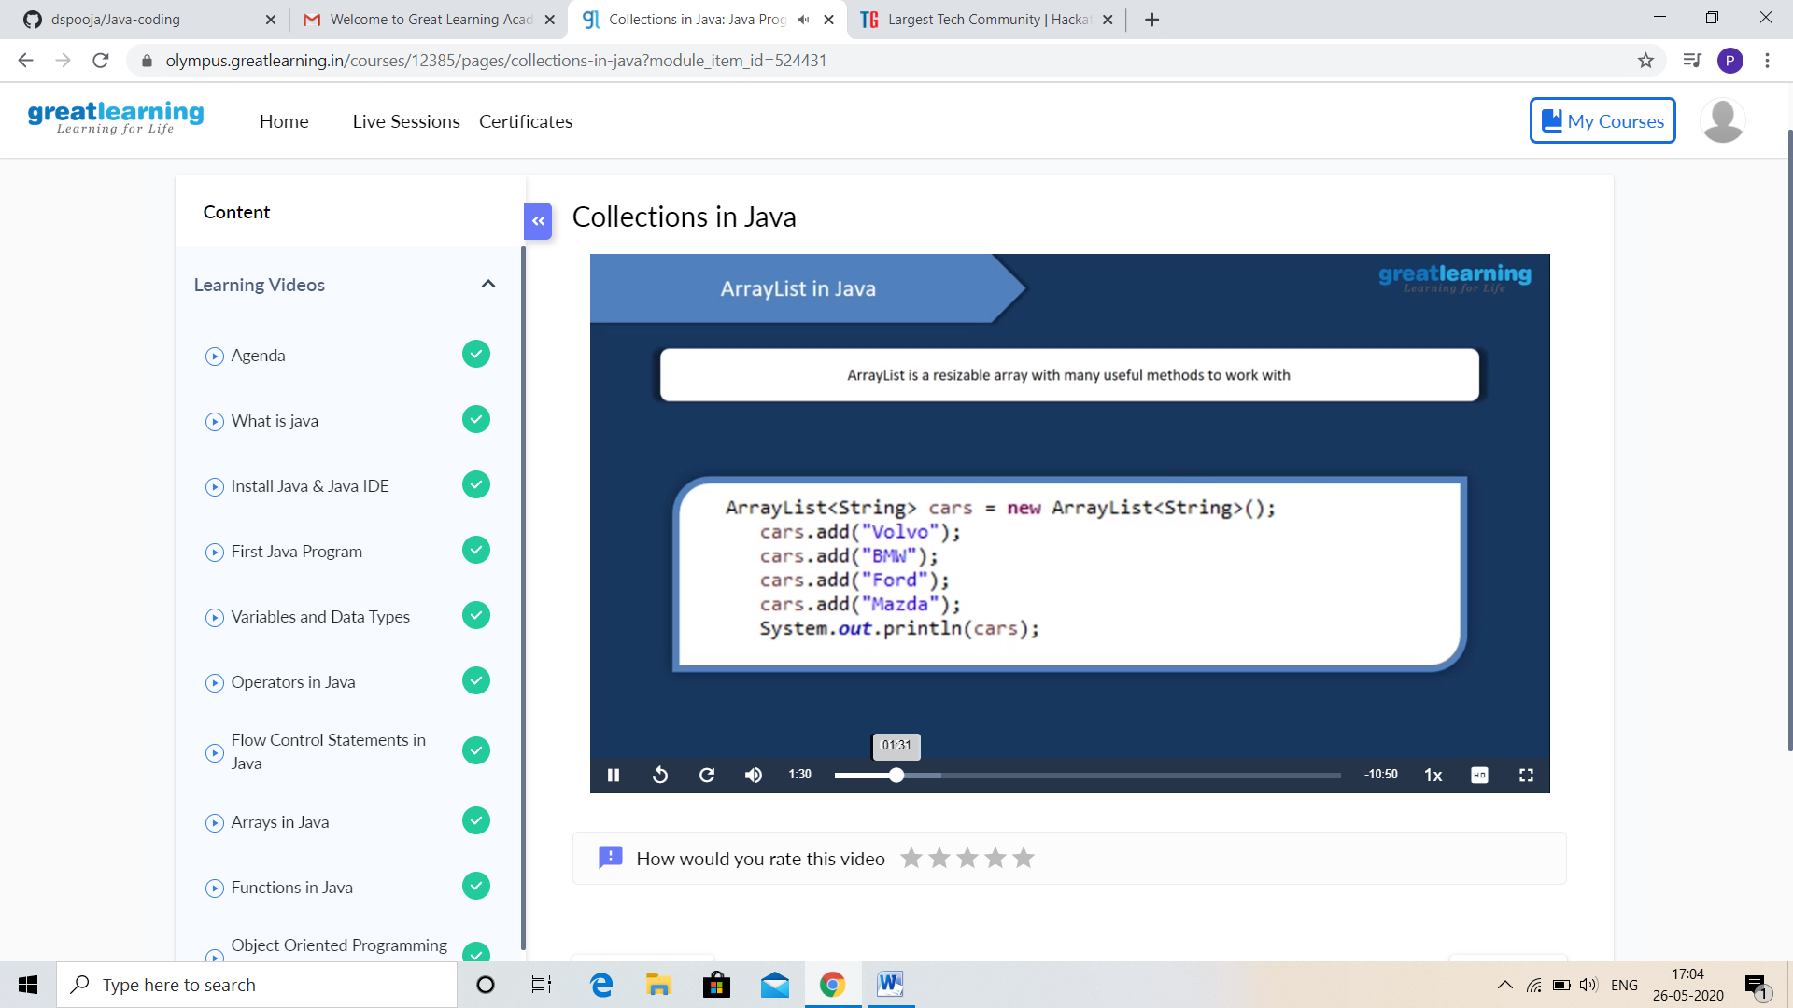

And I successfully completed the course. This is my certificate

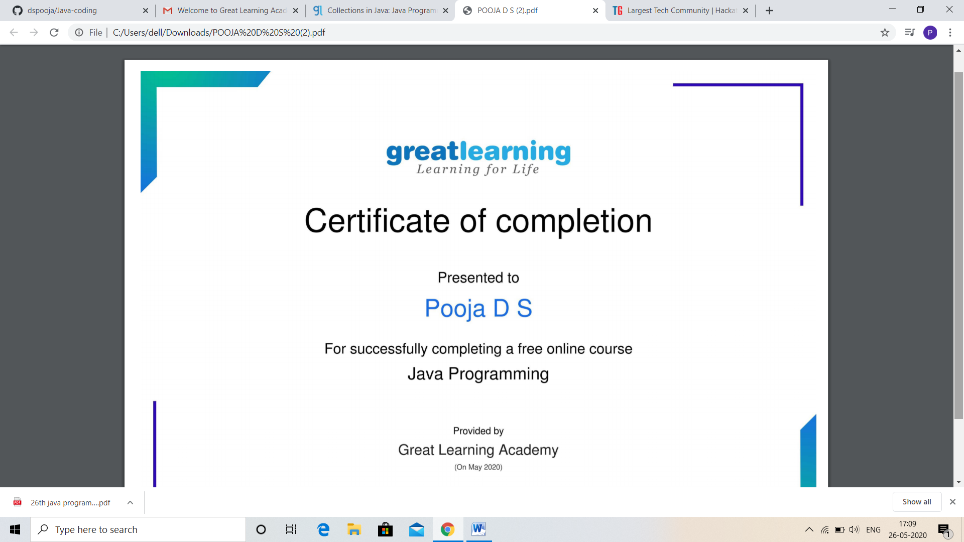

CODING CHALLENGES DETAILS:

Problem statement 1:

Given an array A of size N where the array elements contain values from 1 to N with duplicates, the task is to find total number of subarrays which start and end with the same element.

Input:A[]={1,2,1,5,2}  
Output:7  
Explanation:  
Total 7 sub-array of the given array are {1}, {2}, {1}, {5}, {2}, {1, 2, 1} and {2, 1, 5, 2} are start and end with same element.

Solution : Uploaded it in github

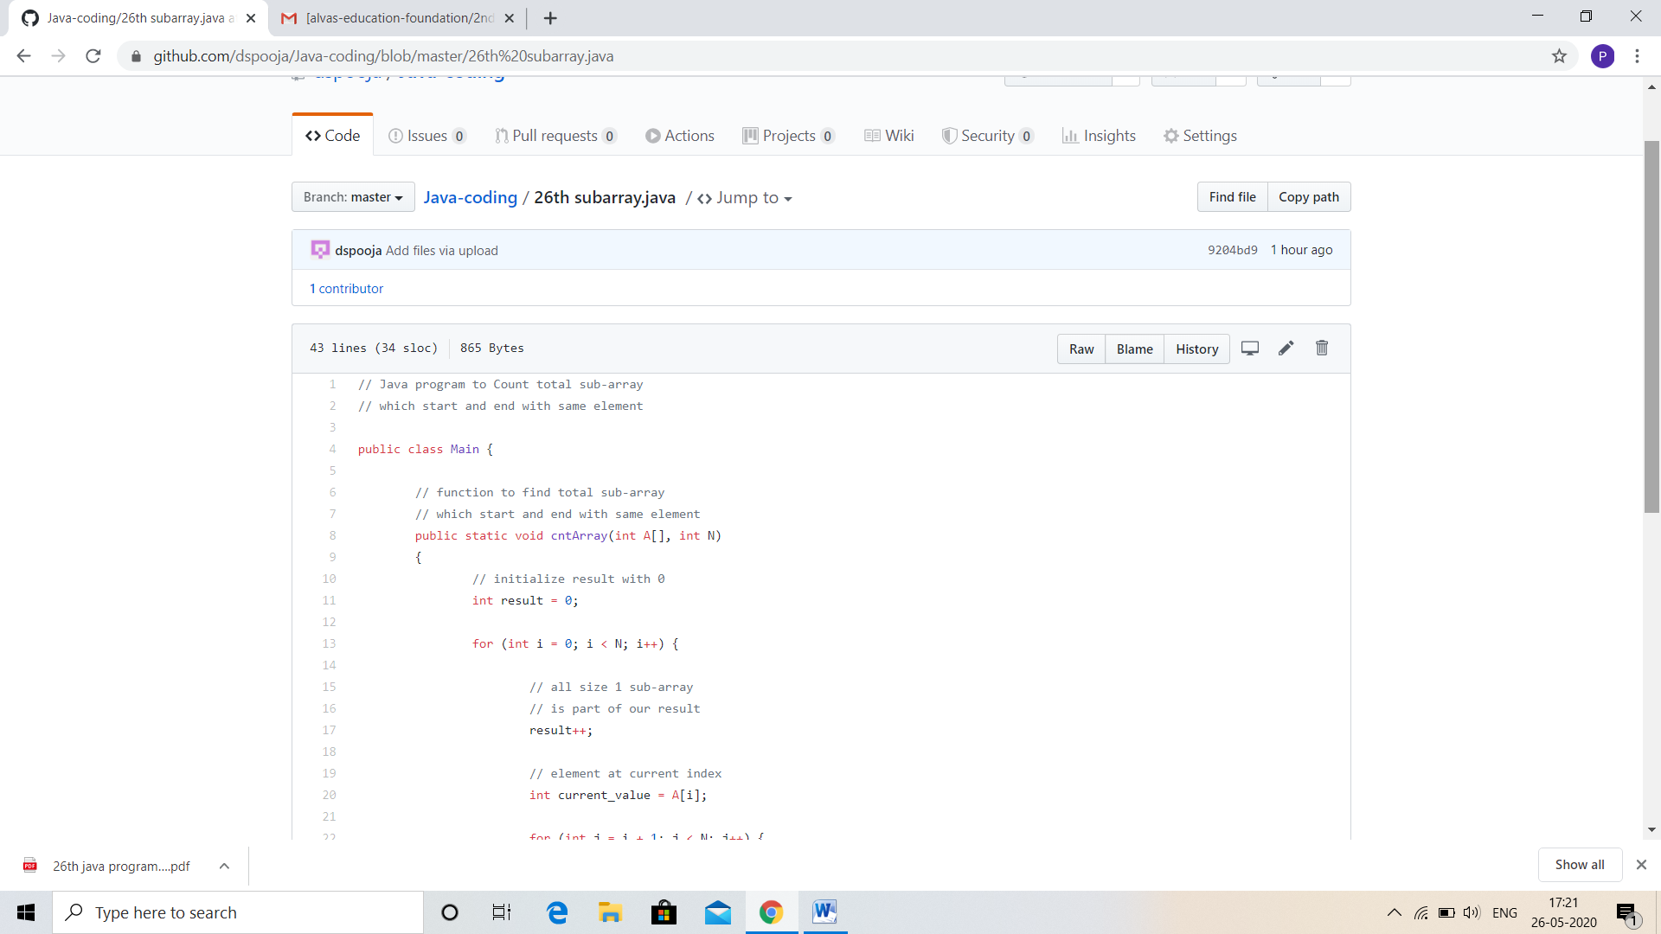

Problem statement 2:

Write a program in C to print all permutations of a given string using pointers.

**Input:**  
Enter the Input String: abcd

**Expected Result:**

The permutations of the string are :  
abcd abdc acbd acdb adcb adbc bacd badc bcad bcda bdca bdac cbad cbda cabd cadb cdab cdba dbca dbac dcba dcab dacb dabc

Solution: Uploaded in github.

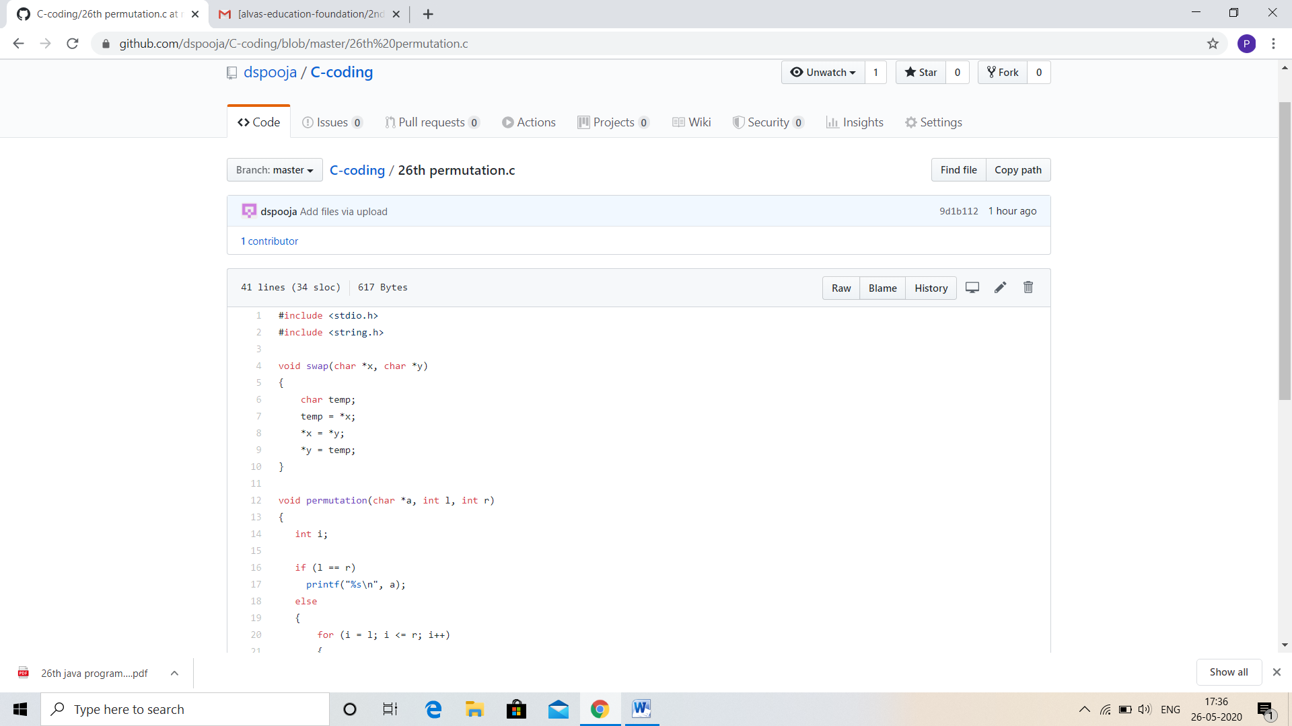

Problem Statement 3:

Write a Java Program To remove all the 10 in the given array

Return a version of the given array where all the 10's have been removed. The remaining elements should shift left towards the start of the array as needed, and the empty spaces a the end of the array should be 0. So {1, 10, 10, 2} yields {1, 2, 0, 0}. You may modify and return the given array or make a new array.  
Example  
withoutTen([1, 10, 10, 2]) → [1, 2, 0, 0]  
withoutTen([10, 2, 10]) → [2, 0, 0]

Input: First line should read number of array elements. Second Line should read the array elements which includes atleast two 10.

Output: Array which contains elements without 10. Refer the examples.

